**Maths/LA/Tutorial/Ch7**

Q1 Lay/Ch6.5/pg362/Ex1

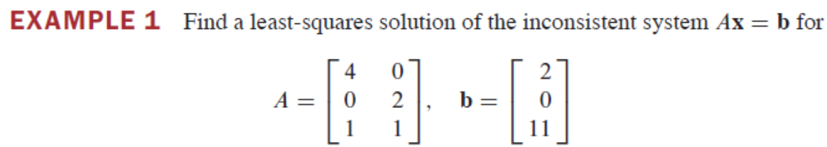

Q2) Lay/Ch6.5/pg364/Ex4

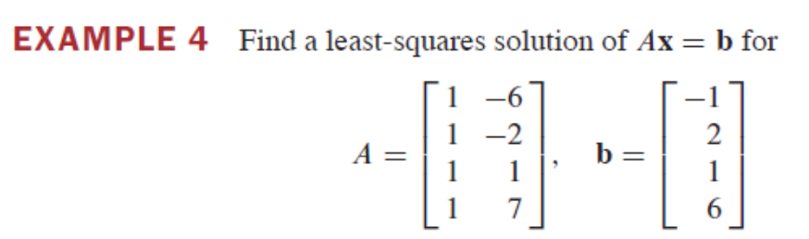

Q3) Lay/pg 362/Ex2, what is the difference of this solution to Example 1

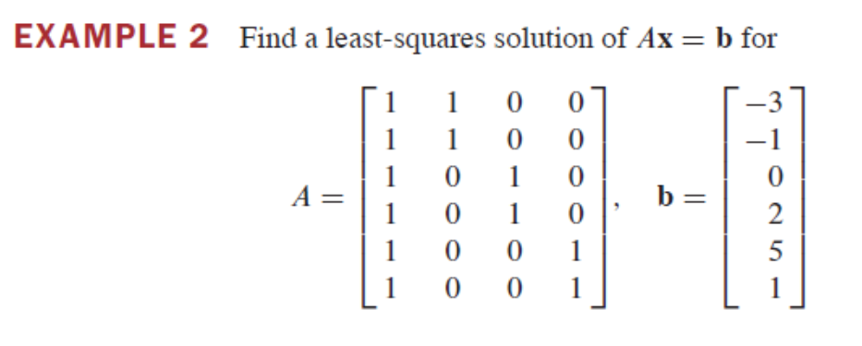

Q4) Lay/ch6.5/pg 366/Q14/

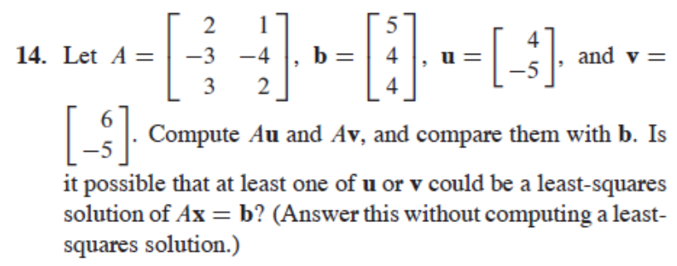

Q5) Lay/ch6.5/pg366/Q17+18

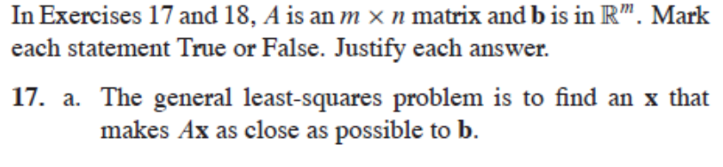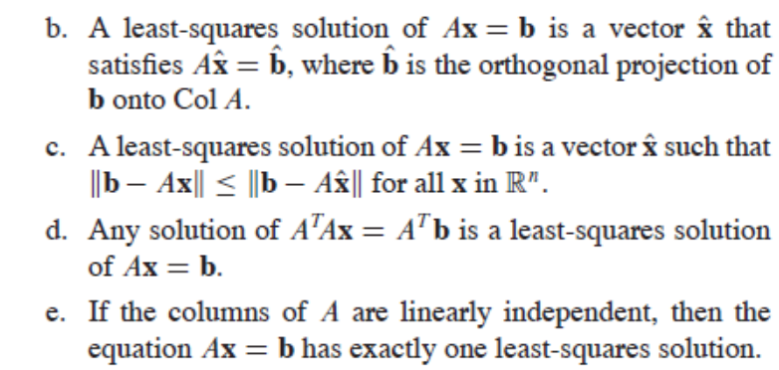

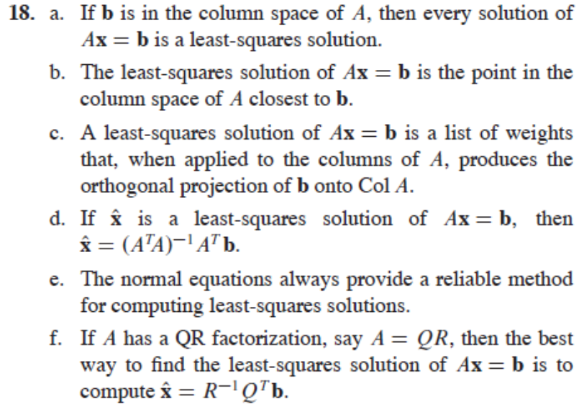

Q6) Lay/ch6.5/pg367/Q19+20+21

Proof Theorem 14:

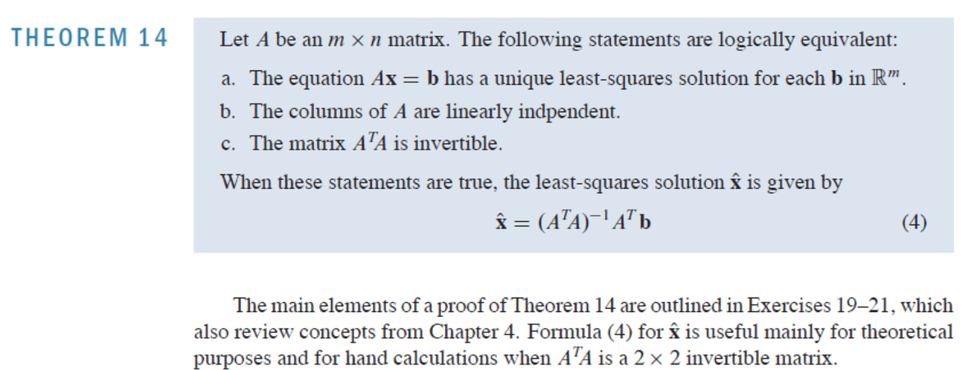

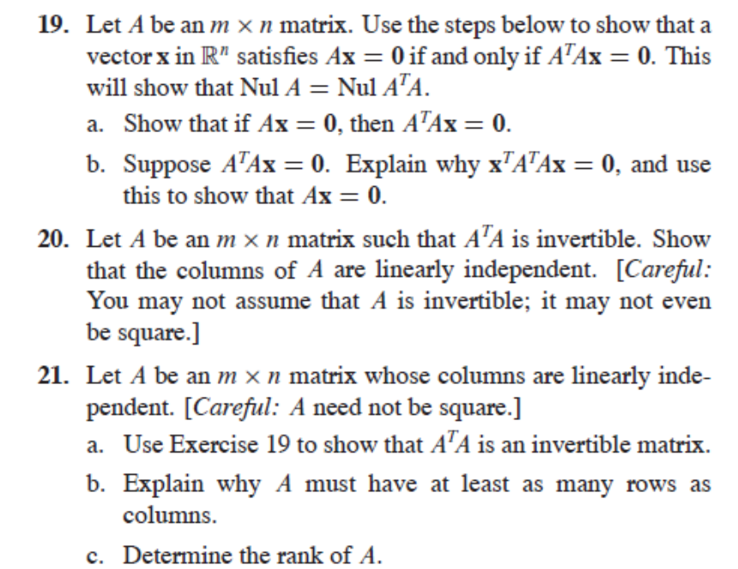

============== End of Tutorial =================